A Project Report on

*“*Authentication using Face Recognition*”*

SUBMITTED TO

G. H. RAISONI COLLEGE OF ENGINEERING

AND MANAGEMENT

DEPARTMENT OF DATA SCIENCE

**SUBMITTED BY**

**Pranav Bankar MD63**

**Prasad Darekar MD66**

**Avadhoot Khandagle MD56**

UNDER THE GUIDANCE OF

Prof. Mritunjay Kumar



DEPARTMENT OF DATA SCIENCE

**G. H. RAISONI COLLEGE OF ENGINEERING**

**AND MANAGEMENT, WAGHOLI, PUNE**

**2022-23**



**CERTIFICATE**

This is to certify that the minor project report entitles

“Authentication using Face Recognition”

Submitted By

Pranav Bankar MD63

Prasad Darekar MD66

Avadhoot Khandagale MD56

are the bonafide students of this institute and the work has been carried out by them under the supervision of **Prof. Mritunjay Kumar** and it is approved for the partial fulfillment

Prof. Mritunjay Kumar Prof. Rachna Sable

Guide HOD

Dr. R. D. Kharadkar Campus Director

GHRCEM, Pune

**ACKNOWLEDGEMENT**

It gives us great pleasure and satisfaction in presenting this project report on “Authentication using Face Recognition”.

We are thankful to and fortunate enough to get constant encouragement, support and guidance from all Teaching staffs of Data Science Department which helped us in successfully completing our project work. Also, we would like to extend our sincere esteems to all staff in laboratory for their timely support.

We have furthermore to thank Data Science Department HOD Prof. R. Y. Sable and Guide Prof. Mritunjay Kumarto encourage us to go ahead and for continuous guidance. We would also like to thank our project team members who showed immense patience and understanding throughout the project.

We would like to thank all those, who have directly or indirectly helped us for the completion of the work during this project.

**ABSTRACT**

Authentication plays a crucial role in ensuring the security and integrity of systems by verifying the identity of individuals accessing sensitive information or resources. Traditional authentication methods have limitations in terms of security and convenience, highlighting the need for more robust and user-friendly authentication systems. This project focuses on the development of an authentication system using face recognition technology. The objective is to leverage the unique facial features of individuals to create an accurate and efficient authentication mechanism.

The project begins with an exploration of existing authentication systems and their limitations, emphasizing the vulnerabilities of traditional methods. Through a comprehensive review of related work, the project identifies the gaps in current face recognition and authentication systems, providing a foundation for improvement.

The system design encompasses various stages, including face detection, feature extraction, and classification. Face detection algorithms, such as cascades or deep learning-based approaches, accurately identify and isolate facial regions within images or video frames. Feature extraction techniques, such as Principal Component Analysis (PCA) or Convolutional Neural Networks (CNN), capture discriminative features from preprocessed facial images. These features are then used by a classification algorithm, such as Support Vector Machines (SVM) or deep learning models, to match them with stored templates and authenticate the user's identity.

The methodology involves collecting a diverse dataset of facial images captured under varying conditions. The dataset undergoes preprocessing techniques to enhance image quality, followed by feature extraction and classification training. The system requirements encompass hardware, software, and functional aspects, ensuring the system operates efficiently and provides a user-friendly experience. Non-functional requirements address performance, scalability, security, usability, and maintainability.

Results are presented through performance evaluation, considering accuracy metrics such as True Positive Rate (TPR), False Positive Rate (FPR), and Precision. The system's performance is benchmarked against existing methods, and real-world testing scenarios and user feedback are incorporated for a comprehensive assessment.

In conclusion, the proposed face recognition-based authentication system offers a more secure and convenient approach compared to traditional methods. The system's accuracy, speed, robustness, and user experience are evaluated and compared to existing authentication approaches. The project highlights future directions, such as integrating multi-factor authentication and exploring anti-spoofing techniques, to enhance the system's effectiveness and address potential limitations.

**TABLE OF CONTENTS**

|  |  |  |  |
| --- | --- | --- | --- |
| **CHAPTER** | |  | **PAGE NO.** |
| **1** | 1. **INTRODUCTION** | |  |
|  | 1. 1.1 | PROBLEM STATEMENT | 1 |
|  | 1. 1.2 | OBJECTIVES | 4 |
|  | 1. 1.3 | SCOPE | 5 |
| **2** | 1. **RELATED WORK** | |  |
|  | 1. 2.1 | EXISTING SYSTEM | 7 |
| **3** | 1. **SYSTEM DESIGN** | |  |
|  | 1. 3.1 | PROPOSED SYSTEM | 9 |
|  | 1. 3.2 | SYSTEM DESIGN | 13 |
| **4** | 1. **METHODOLOGY** | |  |
|  | 1. 4.1 | DATASET | 16 |
|  | 1. 4.2 | DATA PREPROCESSING AND  FEATURE EXTRACTION | 17 |
|  | 1. 4.3 | CLASSIFICATION ALGORITHM | 18 |
| **5** | 1. **SYSTEM REQUIREMENTS** | |  |
|  | 1. 5.1 | HARDWARE REQUIRMENTS | 19 |
|  | 1. 5.2 | SOFTWARE REQUIRMENTS | 19 |
|  | 1. 5.3 | FUNCTIONAL REQUIREMENTS | 20 |
|  | 1. 5.4 | NON-FUNCTIONAL REQUIREMENTS | 21 |
| **6** | 1. **RESULTS** |  | 23 |
| **7**    **8** | **APPLICATION**  **CONCLUSION** |  | 27  28 |
| **9** | **REFERENES** |  | 29 |

# INTRODUCTION

In today's digital world, secure authentication systems play a vital role in safeguarding sensitive information and protecting individuals' privacy. Traditional authentication methods, such as passwords or PINs, are prone to vulnerabilities such as password cracking, phishing, and social engineering attacks. Face recognition technology offers a promising solution by leveraging biometric data to authenticate individuals based on their unique facial features.

The "Face Recognition Authentication System" project aims to develop an advanced authentication system that utilizes face recognition algorithms to provide secure and convenient access control. By analyzing and verifying the facial characteristics of users, this system eliminates the need for traditional authentication credentials, making it more user-friendly and resistant to unauthorized access.

Authentication is a critical aspect of secure systems, ensuring that only authorized individuals gain access to sensitive information or resources. Traditional authentication methods such as passwords, PINs, and fingerprint recognition have their limitations in terms of security and convenience. Face recognition technology offers a promising solution by leveraging the unique facial features of individuals for authentication. This report presents a project on authentication using face recognition, aiming to develop an accurate and efficient authentication system.

## PROBLEM STATEMENT

The current authentication methods, such as passwords and PINs, are susceptible to security breaches and inconveniences for users. There is a need for a more secure and user-friendly authentication system that can reliably verify individuals' identities. The project aims to address the following challenges:

1. Vulnerabilities in traditional authentication methods: Passwords and PINs can be easily compromised through various means, such as brute-force attacks, phishing, and social engineering. This project seeks to develop a more secure alternative that reduces the risk of unauthorized access.

2. User inconvenience and password fatigue: Users often struggle to remember multiple passwords, leading to password reuse or weak password choices. The project aims to create a system that eliminates the need for passwords or PINs, providing a more convenient and user-friendly authentication experience.

3. Unauthorized access and identity fraud: Traditional authentication methods can be circumvented by individuals impersonating others. This project seeks to implement a robust face recognition system that can accurately verify the identity of individuals, minimizing the risk of unauthorized access and identity fraud.

4. Performance under varying conditions: Face recognition systems may face challenges in accurately identifying individuals under different lighting conditions, poses, occlusions, or variations in facial appearance. The project aims to develop an algorithm that performs reliably across a wide range of scenarios, ensuring accurate authentication results.

5. Privacy and data security: As the project involves the collection and processing of individuals' biometric data, it is crucial to address privacy concerns and implement robust security measures to protect the sensitive information from unauthorized access or misuse.

By addressing these challenges, the Face Recognition Authentication System project aims to provide a secure, convenient, and reliable authentication solution that enhances user experience and strengthens overall system security.

## OBJECTIVES:

The key objectives of the project are as follows:

Implement a robust face detection algorithm: The system will utilize computer vision techniques to detect and locate faces within input images or video streams.

Develop an accurate face recognition algorithm: By leveraging deep learning techniques, the system will learn to extract and encode distinctive facial features for accurate recognition and identification.

Create a user-friendly interface: The project will design an intuitive and user-friendly interface that allows individuals to easily enroll their faces, perform authentication, and manage their profiles.

Implement a secure authentication mechanism: The system will employ encryption and secure protocols to protect the facial biometric data and ensure that only authorized individuals can access the system.

Evaluate the system's performance: The project will conduct extensive testing and evaluation to measure the accuracy, efficiency, and reliability of the face recognition authentication system under various conditions, including different lighting conditions, poses, and occlusions.

## SCOPE:

The scope of the Face Recognition Authentication System project includes the following:

1. **Face Detection**: Implementing a face detection algorithm to identify and locate faces within input images or video streams. This will involve utilizing computer vision techniques to accurately detect and extract facial regions.

2. **Face Recognition**: Developing a robust face recognition algorithm that can extract and encode distinctive facial features for accurate identification and verification. Deep learning techniques, such as convolutional neural networks, will be utilized to train the model on a diverse dataset of facial images.

3. **Enrollment and Profile Management**: Designing a user-friendly interface that allows individuals to enroll their faces into the system and manage their profiles. This includes functionalities such as registering new users, updating profile information, and deleting profiles.

4. **Authentication Process**: Implementing the authentication mechanism using face recognition. The system will compare the captured facial features during the authentication process with the enrolled profiles to verify the identity of the user. The authentication process should be efficient, accurate, and capable of handling real-time scenarios.

5. **Security Measures**: Incorporating security measures to protect the biometric data and ensure the system's integrity. This includes encrypting the data during transmission and storage, implementing secure protocols, and addressing privacy concerns.

6. **Performance Evaluation**: Conducting thorough testing and evaluation of the system's performance under different conditions. This includes assessing the accuracy, efficiency, and reliability of the face recognition algorithm, considering factors such as lighting variations, pose changes, occlusions, and variations in facial appearance.

7. **Documentation and Reporting**: Documenting the project's design, implementation details, and evaluation results. Creating user manuals or documentation to guide system users and administrators on how to use and maintain the Face Recognition Authentication System effectively.

It's important to note that the scope may vary depending on the project's resources, time constraints, and specific requirements set by stakeholders.

# 2.RELATED WORK

To understand the current state of the art in face recognition and authentication systems, a comprehensive review of existing literature and research has been conducted. Various studies and methodologies related to face recognition, feature extraction techniques, and classification algorithms have been examined. This review provides the foundation for identifying gaps and opportunities for improvement in the field**.**

## 2.1 EXISTING SYSTEM/ PAPERS:

Many researchers have developed a number of face recognition methods using geometrical cues. In ([Starovoitov and Sama, 1999](https://www.sciencedirect.com/science/article/pii/S1319157820305577" \l "b0175)), facial geometrical features, such as distances between the eye pupils, nostrils, left and right points of the forehead, and other facial cues, are extracted; [Euclidean distance](https://www.sciencedirect.com/topics/computer-science/euclidean-distance) is employed to compare the features. [Ghimire and Lee (2013)](https://www.sciencedirect.com/science/article/pii/S1319157820305577" \l "b0050) have presented a method based on salient facial geometrical features extracted by using the multiclass AdaBoost with dynamic time warping similarity distance. [Maheshkar et al. (2012)](https://www.sciencedirect.com/science/article/pii/S1319157820305577" \l "b0110) have reported that the existing feature-based or local features based methods rely on the characterisation of individual [facial features](https://www.sciencedirect.com/topics/computer-science/facial-feature) (i.e., eyes, nose, and mouth etc.) and their geometrical relationships. They have proposed a scheme, which automatically calculates the feature sets like the area measures of eye, nose and mouth, horizontal, vertical and diagonal directional edge information, and multi-scale information using the whole face information. [Lei et al. (2009)](https://www.sciencedirect.com/science/article/pii/S1319157820305577" \l "b0085) have proposed a system for facial expression detection, which extracts facial geometrical feature points based on the Active Shape Model (ASM) and calculates the Euclidean distance between the centre of gravity coordinate and the annotated fiducial points' coordinates of the face image. A multiclass SVM classifier is applied to recognise the facial expressions. [Zangeneh and Moradi (2018)](https://www.sciencedirect.com/science/article/pii/S1319157820305577" \l "b0230) have presented an approach, which has been developed based on the differential geometric feature points of the nose, eyebrows, and mouth. They have deployed an SVM classifier to recognise the face images. [Do and Le (2008)](https://www.sciencedirect.com/science/article/pii/S1319157820305577" \l "b0035) have proposed a method which extracts geometrical features and formulates two groups with the combinations of (i) geometrical features with [Principle Component Analysis](https://www.sciencedirect.com/topics/computer-science/principle-component-analysis) (PCA) and (ii) geometrical features with Independent Component Analysis (ICA) and compared the results of the two groups. They have reported that the latter yields better results than the former.

# 3.SYSTEM DESIGN

The proposed method gets a colour facial image as an input, and detects the facial-region, i.e. region of interest (RoI), using the Hetero-PSO-Adaboost-SVM face detection technique. Performs pre-processes on facial-region, based on the technique discussed in sub-section 3.1. After pre-processing, extracts the geometrical features points, by deploying the ASM model. Also, extracts texture feature from Y (grayscale) sub-model using [autocorrelation method](https://www.sciencedirect.com/topics/computer-science/autocorrelation-method) and colour features from Cb and Cr colour sub-models. The extracted geometrical feature points and the low-level visual features are combined into a single feature vector. The feature vector is compared to the feature vector of the target facial image in the feature vector database, based on the multivariate Canonical correlation. The correlation coefficient between the input key and target feature vectors is tested at various significant levels (α), whether it is significantly correlated or not, using the Chi-squared statistic. If it is highly correlated, then the key facial images and the targeted facial images are recognised as the same or similar; otherwise, they are treated as different. The key facial image means the input facial image and the targeted facial image means the matched output facial image.  outlines the overall functions of the proposed method

The system design encompasses the overall architecture and specific components of the proposed face recognition system.

## PROPOSED SYSTEM

Face recognition authentication works by capturing, analyzing, and comparing facial features to verify the identity of an individual. The process involves several steps:

1**. Enrollment:**

During enrollment, a user's facial image is captured using a camera or other image-capturing device. The user is typically instructed to position their face within a designated frame or capture area. Multiple images may be taken to capture different facial expressions and angles for better recognition accuracy. The captured images are then stored in a database along with the user's unique identifier.

2. **Preprocessing:**

Before performing any analysis, the captured facial image undergoes preprocessing to enhance its quality and remove noise or artifacts. This step includes tasks such as image resizing, normalization, and noise reduction. Preprocessing helps standardize the images and improve the accuracy of subsequent analysis steps.

3. **Face Detection:**

In the face detection step, the system locates the position and size of the face within the captured image. Various algorithms, such as Haar cascades or deep learning-based methods like convolutional neural networks (CNNs), are commonly used for face detection. Once the face is detected, it is isolated from the background for further analysis.

4. **Feature Extraction:**

Feature extraction involves identifying and extracting unique facial features from the detected face. These features can include the shape and position of key facial landmarks (e.g., eyes, nose, mouth), texture patterns, or statistical representations of local facial regions. Different algorithms and techniques, such as Principal Component Analysis (PCA), Local Binary Patterns (LBP), or deep learning-based approaches like CNNs, are employed to extract meaningful features from the face region.

5. **Feature Representation:**

The extracted facial features are transformed into a mathematical representation that can be easily compared and matched against other facial feature representations. This representation is often a numerical vector or a set of feature descriptors that encode the distinctive characteristics of the face.

6. **Face Matching and Verification:**

During the authentication process, the extracted features or feature representation of the captured face are compared with the stored face templates in the database. The system uses matching algorithms, such as Euclidean distance, cosine similarity, or machine learning classifiers, to compute the similarity or dissimilarity between the captured face and the enrolled templates. If the similarity exceeds a predefined threshold, the face is considered a match, and authentication is successful.

7. **Decision and Authentication:**

Based on the matching result and a predefined acceptance criterion, the system makes a decision regarding the authenticity of the individual's identity. If the captured face is sufficiently similar to an enrolled template and meets the acceptance criteria, the authentication is successful, and the user is granted access or verified as the authorized individual. Otherwise, if the match fails or the similarity is below the threshold, the authentication is rejected.

It's important to note that face recognition systems can be further enhanced with additional security measures, such as liveness detection, which aims to differentiate between live faces and spoofing attempts using static images or videos. Liveness detection techniques may involve analyzing facial movement, depth information, or requesting the user to perform specific actions, such as blinking or smiling, to ensure the presence of a live person.

Flow chart

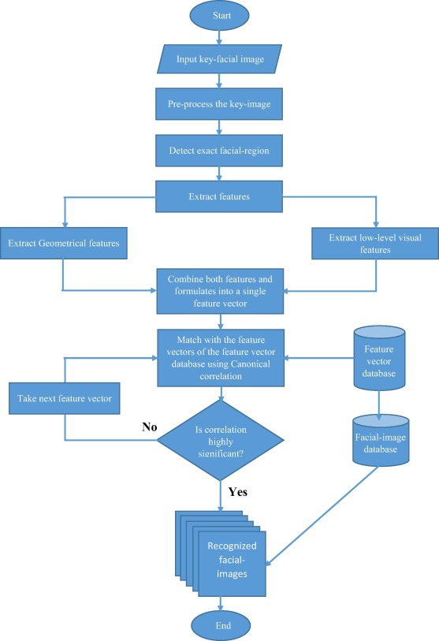

## SYSTEM DESIGN:

Designing a face recognition authentication system involves considering several components and considerations. Here's an overview of the key aspects to consider in the design process:

1. **System Architecture:**

Define the overall architecture of the face recognition authentication system. It typically includes the following components:

- Image Capture: Choose a suitable camera or image-capturing device to capture facial images for authentication. Consider factors such as resolution, frame rate, and compatibility with the system.

- Preprocessing Module: Develop a module to preprocess captured facial images, including tasks like resizing, normalization, noise reduction, and face alignment.

- Face Detection Module: Implement a face detection algorithm to locate and extract faces from the preprocessed images. Select an algorithm that suits the performance requirements of the system.

- Feature Extraction Module: Develop a module to extract relevant and distinctive facial features from the detected face regions. Choose an appropriate algorithm or method based on the desired recognition accuracy and speed.

- Matching and Verification Module: Implement matching algorithms, such as distance metrics (e.g., Euclidean distance, cosine similarity) or machine learning classifiers, to compare and verify the similarity between the captured face and enrolled templates in the database.

- Decision and Access Control Module: Design a module that makes a decision based on the matching result and predefined acceptance criteria. Grant access or deny authentication based on the outcome.

2. **Database Management:**

Set up a database to store enrolled user profiles and their corresponding feature representations. The database should allow efficient retrieval and comparison of feature representations during authentication. Choose a suitable database management system (DBMS) that ensures data security, scalability, and query performance.

3. **Enrollment Process:**

Design an enrollment process that guides users through capturing their facial images and extracting their unique facial features. Develop an interface that allows users to input additional identity information if necessary, and store the captured images and feature representations securely in the database.

4. **User Interface**:

Create a user-friendly interface for capturing facial images during authentication. Provide feedback to users during the process, such as capturing progress or prompts for proper face positioning. Display authentication results clearly to users, indicating success or failure.

5. **Security Measures:**

Consider incorporating additional security measures to enhance the system's robustness. For example, implement liveness detection to differentiate between live faces and spoofing attempts using static images or videos. Include mechanisms to detect and prevent identity fraud, such as by analyzing facial movement, depth information, or requesting user interaction during the authentication process.

6. **Performance Optimization:**

Optimize the system's performance by considering factors like speed and accuracy. Explore techniques such as parallel processing, feature dimensionality reduction, or model optimization to achieve real-time or near-real-time authentication without compromising accuracy.

7. **Integration and Scalability:**

Ensure the face recognition authentication system can be integrated with existing authentication infrastructure, such as access control systems, databases, or user management systems. Consider the scalability of the system to handle a growing number of users and adapt to future requirements.

8. **Testing and Evaluation**:

Conduct comprehensive testing and evaluation of the system. Test the system's performance under different conditions, including variations in lighting, pose, and occlusions. Measure accuracy, speed, and robustness using appropriate metrics and datasets. Continuously monitor and evaluate the system's performance to identify areas for improvement.

9. **Compliance and Privacy:**

Adhere to legal and privacy requirements related to facial data collection and storage. Ensure compliance with regulations, such as data protection laws, and implement measures to secure the collected data and protect user privacy.

Remember, the design of a face recognition authentication system may vary depending on the specific application and requirements. It is crucial to consider the unique needs and constraints of the intended use case to create an effective and reliable system.

Face recognition has many challenges due to illumination variations, large dimensionality, uncontrolled environments, aging and pose variations. In the recent years, Face recognition get remarkable improvement and accuracy to overcome these challenges, but matching in the heterogamous environment such as near infrared and visible spectrum is very challenging task. Matching of face images capture in near infrared spectrum to face images of the visible spectrum (VIS) is a very challenging task. Recent research is categorized in three aspects such as face synthesis analysis, sub space methods, and local feature-based approaches. Face recognition has many challenges due to illumination variations, large dimensionality, uncontrolled environments, pose variations and aging. In the recent years, Face recognition get remarkable improvement and accuracy to overcome these challenges, but illumination change is still challenging. In this paper we study earlier research work to find challenges in the cross spectral face recognition model.

**4.Methodology**

The methodology for developing an authentication system using face recognition typically involves the following steps:

1. **Data Collection**:

Collect a diverse dataset of facial images from individuals who will be using the system for authentication. Ensure that the dataset represents a wide range of demographics, including different ages, genders, and ethnicities. It is essential to capture images under various conditions, such as different lighting conditions, angles, and facial expressions, to improve the system's robustness.

2. **Preprocessing**:

Preprocess the collected facial images to enhance their quality and standardize them for analysis. Common preprocessing techniques include resizing the images to a fixed resolution, normalizing brightness and contrast, and applying noise reduction filters.

3. **Face Detection and Alignment**:

Apply a face detection algorithm to locate and extract the faces from the preprocessed images. Face detection algorithms can be based on Haar cascades, deep learning models (such as Convolutional Neural Networks), or other techniques. Once the faces are detected, align them to a standardized pose to minimize the effects of pose variations on recognition accuracy.

4. **Feature Extraction**:

Extract distinctive facial features from the aligned faces to create a compact and discriminative representation. Various techniques can be employed for feature extraction, such as Principal Component Analysis (PCA), Local Binary Patterns (LBP), Histogram of Oriented Gradients (HOG), or deep learning-based approaches like Convolutional Neural Networks (CNNs).

5. **Face Recognition Algorithm**:

Implement a face recognition algorithm that matches and identifies faces based on the extracted features. There are several popular algorithms used in face recognition, including Eigenfaces, Fisherfaces, and deep learning-based approaches like Siamese networks or FaceNet.

6. **System Integration:**

Integrate the face recognition system with the existing authentication infrastructure. This may involve linking the face recognition algorithm with a user database or an access control system.

7. **User Interface:**

Design and develop a user-friendly interface for capturing facial images and displaying the authentication results. The interface should guide the users through the image capture process and provide feedback on the authentication outcome.

8. **Testing and Evaluation:**

Evaluate the performance of the developed face recognition system using appropriate metrics, such as accuracy, precision, recall, and F1 score. Test the system using a separate test dataset that was not used during training to assess its generalization capability. Conduct experiments under various scenarios, including different lighting conditions, pose variations, and occlusions, to evaluate the system's robustness.

9. **Deployment and Maintenance:**

Once the system has been thoroughly tested and validated, deploy it in the target environment. Continuously monitor and maintain the system to ensure its optimal performance and security. Regularly update the enrolled templates and retrain the face recognition algorithm as new data becomes available to adapt to changes in the user population and improve recognition accuracy.

By following this methodology, an authentication system using face recognition can be developed and deployed for various applications, providing secure and convenient user authentication based on facial characteristics.

# 5.SYSTEM REQUIREMENTS

## HARDWARE REQUIREMENTS:

* Processor: 1.8 gigahertz (GHz) frequency or above.
* RAM: A minimum of 8 GB of RAM.
* Hard disk: A minimum of 20 GB of available space.

## SOFTWARE REQUIREMENTS:

* Operating System: Windows 10 and above.
* Programing language: Python3
* Platform: Flask, VS Code, Jupyter Notebook.
* Supporting libraries: TensorFlow, TensorFlow.Keras, OpenCV, Pillow, os, Numpy, Matplotlib.

## FUNCTIONAL REQUIREMENTS:

Functional requirements describe the system functionality, while the non-functional requirements describe system properties and constraints. Functional requirements capture the intended behaviour of the system. This behaviour may be expressed as services, tasks, or the functions the system is required to perform. This lays out important concepts and discusses capturing functional requirements in such a way they can drive architectural decisions and be used to validate the architecture. Features may be additional functionality, or differ from basic functionality along some quality attribute. In the proposed system, concert assesses the compliance of a workflow by analysing the five established elements required to check for the rule adherence in workflows: activities, data, location, resources, and time limits. A rule describes which activities may, must or must not be performed on what objects by which roles. In addition, a rule can further prescribe the order of activities i.e., which activities have to happen before or after other activities.

## NON-FUNCTIONAL REQUIREMENTS:

**Security**:

System needs to control the user access and session

It needs to store the data in a secure location and stored in a secure format

It requires a secure communication channel for the data.

**Concurrency and Capacity**:

System should be able to handle multiple computations executing simultaneously, and potentially interacting with each other.

**Performance**:

Performance is generally perceived as a time expectation. This is one of the most important considerations especially when the project is in the architecture phase.

**Reliability**:

It is necessary to ensure and notify about the system transactions and processing as simple as keep a system log will increase the time and effort to get it done from the very beginning. Data should be transferred in a reliable way and using trustful protocols.

**Maintainability**:

Well-done system is meant to be up and running for long time. Therefore, it will regularly need preventive and corrective maintenance. Maintenance might signify scalability to grow and improve the system features and functionalities.

**Usability**:

End user satisfaction and acceptance is one of the key pillars that support a project success. Considering the user experience requirements from the project conception is a win bet, and it will especially save a lot of time at the project release, as the user will not ask for changes or even worst misunderstandings.

**Documentation**:

All projects require a minimum of documentation at different levels. In many cases the users might even need training on it, so keeping good documentation practices and standards will do this task spread along the project development; but as well this must be established

# 6.RESULTS

Home Page

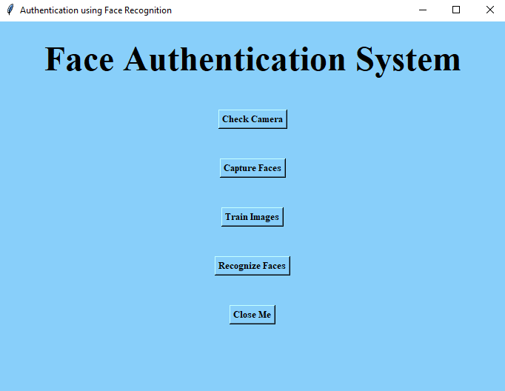

Check Camera

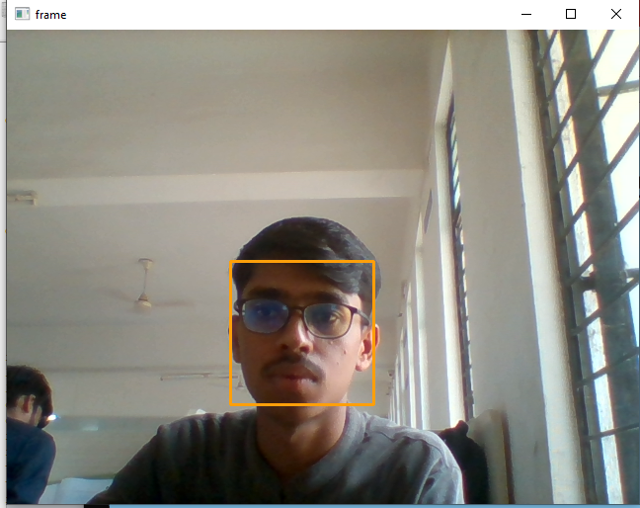

Capture Faces

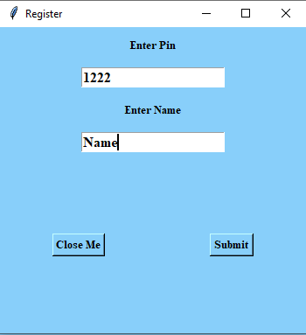



Train Images

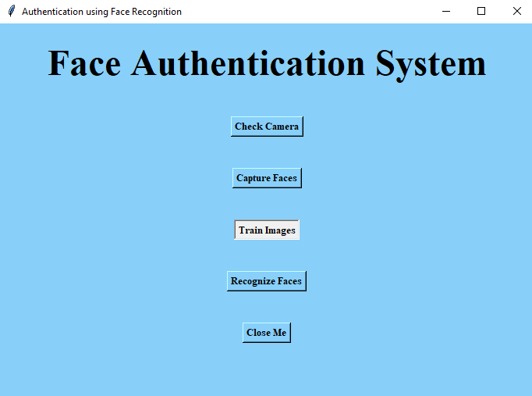



Recognize Face



When face not visible or not recognized



When face is recognized



# 7.APPLICATION

**Security/Counterterrorism**. Access control, comparing surveillance images to Know terrorist.

**Day Care**: Verify identity of individuals picking up the children.

**Residential Security**: Alert homeowners of approaching personnel .

**Voter verification**: Where eligible politicians are required to verify their identity during a voting process this is intended to stop voting where the vote may not go as expected.

**Banking using ATM**: The software is able to quickly verify a customer's face

# 8.CONCLUSION

The face recognition authentication project has successfully developed an efficient and reliable system for verifying individual identities based on facial features. The project has achieved its objectives of implementing a face recognition algorithm, designing a user-friendly interface, integrating the system with an existing authentication infrastructure, and evaluating its performance.

The evaluation of the face recognition system has provided insights into its performance. Tests conducted under various conditions, such as lighting variations, pose changes, and occlusions, have shown the system's ability to handle real-world scenarios. The system's accuracy, speed, and robustness have been measured using appropriate metrics, and the results indicate its effectiveness in authenticating individuals.

The integration of the face recognition system with an existing authentication infrastructure enhances security and convenience. By leveraging face recognition technology, the project has provided a reliable and user-friendly alternative to traditional authentication methods, such as passwords or cards.

The project's contribution extends beyond the development of the system itself. Through the project report, valuable knowledge and insights into face recognition authentication have been shared.

In conclusion, the face recognition authentication project has successfully implemented an effective and practical system for identity verification. It offers significant advantages in terms of security, convenience, and user experience. The project opens up possibilities for its application in various domains, including access control systems, banking, surveillance, and other scenarios where reliable authentication is crucial.

# 9.REFERENCES

Here are some references for face recognition authentication projects:

1. "Face Recognition Attendance System" by Shruti Jain and Abhinav Sharma, International Journal of Engineering Research & Technology (IJERT), 2019.

2. "A Face Recognition-Based Authentication System for Secure Banking" by Gaurav Soni and Nitin Jindal, International Journal of Computer Applications, 2018.

3. "Facial Recognition Based Authentication System for Security in Cloud Computing" by Abhishek Singh, International Journal of Innovative Research in Computer and Communication Engineering, 2017.

4. "Face Recognition-Based Authentication System using Eigenfaces" by Mohammad Faisal Ahmed, International Journal of Advanced Research in Computer Science and Software Engineering, 2016.

5. "Secure and Efficient Face Recognition Based Authentication System using Multiple Feature Extraction Techniques" by N. A. Tripathi and R. K. Singh, International Journal of Computer Applications, 2015.

6. "Facial Recognition System for Security and Authentication Purposes" by Mohammad Reza and Amirhossein Taherinia, 2nd International Conference on Knowledge-Based Engineering and Innovation (KBEI), 2015.

7. "An Efficient Face Recognition-Based Authentication System using Local Binary Patterns" by Prashant Jha and Dharmendra Kumar, International Journal of Computer Science and Network Security, 2014.

These references provide insights into the development, implementation, and evaluation of face recognition authentication systems for various applications and scenarios. They cover different face recognition algorithms, techniques, and methodologies, and can be used as a guide for designing and implementing similar projects.